Information Gathering and Literature Survey

  - Introduction

A decision tree is a flow-chart-like tree structure, where each internal node denotes a test on attribute, each branch represents an outcome of the test, and leaf nodes represent classes or class distributions. Top most node in tree is root node. Internal nodes are denoted by rectangles, and leaf nodes are denoted by ovals.
In order to classify an unknown sample, the attribute values of the sample are tested against the decision tree. A path is traced from the root to a leaf node that holds the class prediction for sample. Decision trees can be easily be converted to classification rules. Decision tree learning is a common method used in data mining. When a businessperson needs to make a decision based on several factors, a decision tree can help identify which factors to consider and how each factor has historically been associated with different outcome of the decision. Data mining tools that produce decision trees create graphical models and text rules that can both predict behavior and explain patterns. End users can easily understand and apply decision trees, so these are very popular data exploration tools.

  - Algorithm

The basic algorithm for decision tree induction is greedy algorithm that constructs decision trees in top-down recursive divide-and-conquer manner. ID3 is basic algorithm for decision tree construction shown in figure (1).
Algorithm: Generate_decision_tree.
Input: The training samples, samples, represented by discrete-valued attributes; set of candidate attributes, attribute-list.
Output: A decision tree.

Method:
- create a node N;
- if samples are all of the same class, C then
- return N as a leaf node labeled with the class C;
- if attribute-list is empty then
- return N as a leaf node labeled with most common class in samples;
- select test-attribute , the attribute among attribute- list with highest information gain;
- label node N with test-attribute;
- for each known value of a_{i} of test-attribute;
- grow a branch from node N for the condition test-attribute = a_{i};
- let s_{i} be set of samples in samples for which test attribute = a_{i};
- if s_{i} is empty then
- attach the leaf labeled with most common class in samples;
- else attach the node returned by Generate_decision_tree(s_{i}, attribute-list-test-attribute);

Figure-1: Basic algorithm for decision tree - induction from training samples

The basic strategy of above algorithm is as follows:

- The tree starts as a single node representing the training samples (step 1).
- If the samples are all of the same class, then the node becomes a leaf and is labeled with the class (step 2 and 3).
- Otherwise, the algorithm uses an entropy-based measure known as information gain. This attribute becomes the “test “or “decision” attribute at a node (step 7).
- A branch is created for each known values of the test attribute, and the samples as partitioned accordingly (step 8-10).
- The algorithm uses the same process recursively to form a decision tree for the sample at each partition. Once an attribute has occurred at a node, it need not be considered in any of the node’s descendents (step 13).
- The recursive partitioning stops only when any of following condition is true:
  - All the samples for a given node belong to same class (step 2 and 3) or
  - There are no remaining attribute on which the samples may further partitioned (step 4).
  - There are no samples for the branch test-attribute = a_{i} (step 11). In this case, a leaf is created with the majority class in samples (step 12).

1.3 Attribute Selection Measure

The information gain measure is used to select the test attribute at each node in the tree. The attribute with highest information gain is chosen as test attribute for the current node. This attribute minimizes the information needed to classify the samples in resulting partition and reflect the least “impurity” in these partitions.

Let S be set consisting of s data sample. Suppose the class label attribute has m distinct values defining m distinct class. C_{i} (for i =1,..., m). Let S_{i} be the number of sample of S in class Ci.

The expected information needed to classify a given sample is given by equation (1.1)

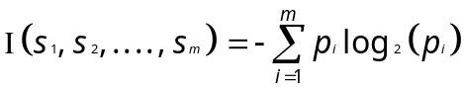 (1.1)

Where P_{i} is probability that an arbitrary sample belongs to classify C_{i} and estimated by s_{i}/s. Note that a log function to base 2 is used since the information in encoded in bits .

1.4 Entropy

It is minimum number of bits of information needed to encode the classification of arbitrary members of S.
Lets attribute A have v distinct value {a₁,.............,a_{v}}.Attribute A can be used to partition S into v subsets, {S₁,S₂,........,S_{v}}, where S_{j} contains those sample in S that have value aj of A. If A were selected as the test attribute, then these subset would corresponds to the branches grown from the node contains the set S. Let S_{ij} be the number of class C_{i}, in a subset by Sj, The entropy or expected information based on partitioning into subset by A, is given by equation (1.2)

. 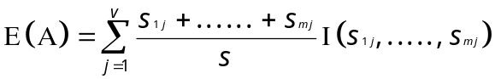 (1.2)

The first term acts as the weight of the jth subset and is the number of samples in the subset divided by the total number of sample in S. The smaller the entropy values the greater purity of subset partitions.
Note that for a given subset Sj,
(1.3)
Where P_{i} is the probability that a sample in Sj belongs to class Ci .
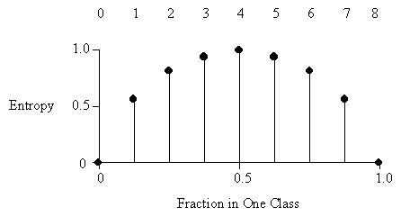

Figure-2: Entropy values distribution

1.5 Information Gain

It is simply the expected reduction in entropy caused by partitioning the examples according to the attribute. More precisely the information gain, Gain(S,A) of an attribute A, relative collection of examples S, is given by equation (1.4)

Gain (A) =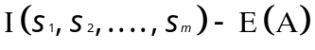 (1.4)

In other words gain (A) is the expected reduction in entropy caused by knowing the value of attribute A. The algorithm computes the information gain of each attribute. With highest information gain is chosen as the test attribute for a given set.
EXPERIMENTATION WITH EXAMPLE

Following table represents a training set of data tuples taken from All-Electronics customer database.

ID | AGE | INCOME | STUDENT | CREDIT_RATING | BUYS_COMP
1 | <=30 | High | No | Fair | No
2 | <=30 | High | No | Excellent | No
3 | 31…..40 | High | No | Fair | Yes
4 | >40 | Medium | No | Fair | Yes
5 | >40 | Low | Yes | Fair | Yes
6 | >40 | Low | Yes | Excellent | No
7 | 31…..40 | Low | Yes | Excellent | Yes
8 | <=30 | Medium | No | Fair | No
9 | <=30 | Low | Yes | Fair | Yes
10 | >40 | Medium | Yes | Fair | Yes
11 | <=30 | Medium | Yes | Excellent | Yes
12 | 31…..40 | Medium | No | Excellent | Yes
13 | 31…..40 | High | No | Fair | Yes
14 | >40 | Medium | No | Excellent | No

Table-1: Training data tuples from the All Electronics customer database

2.1 Expected Information for Database Classification

The class label attribute, buys computer, has two distinct values (namely, {yes, no}); Therefore, there are two distinct classes (m=2). Lets class C₁ corresponds to yes and class C₂ corresponds to no. There are 9 sample of class yes and 5 samples of class no. To compute the information gain of each attribute, we first calculate expected information needed to classify a given sample by equation (2.1)
(2.1)

I(s₁,s₂) = I(9,5) = -(9/14) log₂( 9/14) –( 5/14) log₂( 5/14)

= - (9/14) log₂ (0.6428) – (5/14) log₂ (0.3571)

= - (9/14) {In (0.6428)/In (2)} – (5/14) {In (0.3571)/In (2)}

= - (9/14) {-(0.4419)/(.6975)} – (5/14) {-(1.0297)/(0.6931)}

= - (9/14) {-(0.6375)} – (5/14){-(1.4856)}

= 0.4097 + 0.5305

= 0.940 bits/message.

The expected information needed to classify the given sample is 0.940 bits/message.

  - Gain on attribute age

Next, we need to compute the entropy for each attribute. Let’s start with the attribute age .We need to look at the distribution of yes and no sample for each value of age. We compute the expected information for each of these distributions.

a) For age= “<=30”:
s₁₁=2 s₂₁=3

= - (2/5) log₂ (2/5) – (3/5) log₂ (3/5)

= - (2/5) log₂(0.4) – (3/5) log₂(0.6)

= - (2/5) {In (0.4)/In (2)} – (3/5){ In(0.6)/In(2)}

= - (2/5) {-(0.9162)} – (3/5) {-(0.6)}

= 0.5287+0.4421
= 0.9710 bits/message.

b) For age “31………40”.
s₁₂ = 4 s₂₂ = 0

I (s_{12 ,} s₂₂) ₌ 0.

c) For age “>40”.
s₁₃ = 3 s₂₃= 2

= - (3/5) log₂ (3/5) – (2/5) log₂ (2/5)

= - (3/5) log₂(0.6) – (2/5) log₂(0.4)

= - (3/5) {In (0.6)/In (2)} – (2/5){ In(0.4)/In(2)}

= - (3/5) {-(0.7369)} – (2/5) {-(1.32188)}

= 0.5287+0.4421

= 0.9710 bits/message.

Total expected information needed to classify a given sample calculated by equation (3.2)
. (2.2)
Total expected information needed to classify a given sample on age attribute
E (Age) = 5/14 I(s_{11 ,} s₂₁)+ 4/14 I(s_{12 ,} s₂₂) + 5/14 I(s_{13 ,} s₂₃)
E (Age) = 5/14 (0.971) + 4/14 (0) + 5/14 (0.971)
= 0.694 bits/message
The gain in information for an attribute is calculated by
Gain (A) = I (s₁, s₂,…………, s_{m}) - E (A)
The information gain for age attribute is
Gain (age) = I (s₁,s₂) - E (age)
Gain (age) = 0.971 - 0.740 = 0.231 bits/message.

  - Gain on attribute income

Next, we take attribute income. We need to look at the distribution of yes and no sample for each value of income. We compute the expected information for each of these distributions.
a) For income= “high”:
s₁₁=2 s₂₁=2
= - (2/4) log₂ (2/4) – (3/4) log₂ (2/4)
= - (2/4) log₂(0.5) – (2/4) log₂(0.5)
= - (2/4) {In (0.5)/In (2)} – (2/4){ In(0.5)/In(2)}

= - (2/4) {-(1)} – (2/4) {-(1)}
= 0.5000+0.5000
= 1 bits/message.
b) For income “medium”.
s₁₂ = 4 s₂₂ = 2
= - (4/6) log₂ (4/6) – (2/6) log₂ (2/6)
= - (4/6) log₂(0.666) – (2/6) log₂(0.333)
= - (4/6) {In (0.666)/In (2)} – (2/6){ In(0.333)/In(2)}
= - (4/6) {-(0.5864)} – (2/6) {-(1.58497)}
= 0.3905+0.52826
= 0.9188 bits/message.
c) For income “low”.
s₁₃ = 3 s₂₃=1
= - (3/4) log₂ (3/4) – (1/4) log₂ (1/4)
= - (3/4) log₂(0.75) – (1/4) log₂(0.25)
= - (3/4) {In (0.75)/In (2)} – (1/4){ In(0.25)/In(2)}
= - (3/4) {-(0.4150)} – (1/4) {-(0.2000)}
= 0.3112+0.5000
= 0.8112 bits/message.
Total expected information needed to classify a given sample calculated by equation (2.3)
(2.3)
Total expected information needed to classify a given sample on income attribute
E (income) = 4/14 I (s_{11,} s₂₁) + 6/14 I (s_{12,} s₂₂) + 4/14 I (s_{13,} s₂₃)
E (income) = 4/14 (1) + 6/14 (0.9188) + 4/14 (0.8112)
= 0.9111 bits/message
The gain in information for an attribute is calculated by
Gain (A) = I (s₁, s2,………, sm) - E (A)
The information gain for income attribute is
Gain (income) = I (s₁, s2) - E (income)
Gain (income) = 0.940 - 0.9111 = 0.029 bits/message.

  - Gain on attribute student
Next, we take attribute student. We need to look at the distribution of yes and no sample for each value of student. We compute the expected information for each of these distributions.
a) For student= “No”:
s₁₁=3 s₂₁=4
= - (3/7) log₂ (3/7) – (4/7) log₂ (4/7)
= - (3/7) log₂(0.4285) – (4/7) log₂(0.5714)
= - (3/7) {In (0.4825)/In (2)} – (4/7){ In(0.5714)/In(2)}
= - (2/4) {-(1.224)} – (4/7) {-(0.807363)}
= 0.5239 + 0.4613
= 0.9852 bits/message.
b) For student “yes”.
s₁₂ = 6 s₂₂ = 1
= - (6/7) log₂ (6/7) – (1/7) log₂ (1/7)
= - (6/7) log₂(0.8574) – (1/7) log₂(0.1428)
= - (6/7) {In (0.8574)/In (2)} – (1/7){ In(0.1428)/In(2)}
= - (6/7) {-(0.2223)} – (1/7) {-(2.8073)}
= 0.1903+0.4010
= 0.5913 bits/message.
Total expected information needed to classify a given sample calculated by equation (2.4)
(2.4)
Total expected information needed to classify a given sample on student attribute
E (student) = 7/14 I(s_{11 ,} s₂₁) + 7/14 I(s_{12 ,} s₂₂)
E (student) = 7/14 (0.9852) + 7/14 (0.5913)
= 0.7882 bits/message
The gain in information for an attribute is calculated by
Gain (A) = I (s₁, s2,……, sm) – E (A)
The information gain for income attribute is
Gain (student) = I (s₁, s2) - E (student)
Gain (student) = 0.940 - 0.7882 = 0.151 bits/message.

  - Gain on attribute credit_rating
Next, we take attribute credet_rating.We need to look at the distribution of yes and no sample for each value of credit rating. We compute the expected information for each of these distributions
a) For credit rating= “Fair”
s₁₁=6 s₂₁=2
= - (6/8) log₂ (6/8) – (2/8) log₂ (2/8)
= - (6/8) log₂(0.75) – (2/8) log₂(0.25)
= - (6/8) {In (0.2876)/In (2)} – (2/8){ In(0.25)/In(2)}
= - (6/8) {-(0.41505)} – (2/8) {-(0.2000)}
= 0.3111+0.5000
= 0.81112 bits/message.
b) For credit rating “excellent”
s₁₂ = 3 s₂₂ = 3
= - (3/6) log₂ (3/6) – (3/6) log₂ (3/6)
= - (3/6) log₂(0.500) – (3/6) log₂(0.500)
= - (3/6) {In (0.500)/In (2)} – (3/6){ In(0.500)/In(2)}
= - (3/6) {-(1.0)} – (3/6) {-(1.0)}
= 0.5000+0.5000
= 0.5913 bits/message.
Total expected information needed to classify a given sample calculated by equation (2.5)
(2.5)
Total expected information needed to classify a given sample on credit_rating attribute
E (student) = 8/14 I(s_{11 ,} s₂₁)+ 6/14 I(s_{12 ,} s₂₂)
E (income) = 8/14 (0.8111)+ 6/14 (1)
= 0.8905 bits/message

  - Comparison on Gain

Attribute | Gain
Age | 0.231 bits/message
Student | 0.029 bits/message
Income | 0.151 bits/message
Credit | 0.048 bits/message

Table-2: Gain comparison for All Electronic database

  - Decision Tree for Shop Database
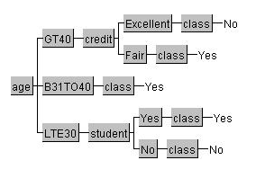
Figure-3: Decision tree representation for shop database

  - Databases used for experimentation

Following Databases are used for construction of Decision-Tree (Gain-method).

ID | Database Name | # of Instances | Attributes | Class
1 | Balloon | 20 | 4 | 2
2 | Car Evaluation | 1728 | 6 | 4
3 | Hepatitis Domain | 155 | 19 | 2
4 | Electronics shop | 14 | 4 | 2
5 | Spect Heart | 267 | 22 | 2
6 | Postoperative Patient | 90 | 8 | 3
7 | Space-Shuttle O-Ring | 23 | 4 | 2
8 | US Voting Records | 435 | 16 | 2
9 | Credit Approval | 690 | 15 | 2
10 | Hayes-Roth | 132 | 5 | 3
11 | Liver-Disorder | 345 | 6 | 2
12 | Tic-Tac-Toe | 958 | 9 | 2
13 | Space Shuttle Auto landing | 15 | 6 | 2

Table-3: Databases used for construction of decision trees
DECISION TREE WITH MINIMAL COST

3.1 Introduction
We construct decision tree by using entropy method, which is used for classification but
It is less efficient method where cost is important factor, so we uses new approach “Decision Tree with Minimal cost” for classification. In this method two important costs are considered i.e. Test Cost
And Misclassification cost for each attribute.
This method plays important role in medicine, especially for medical diagnosis. Health application often requires classifier that minimizes total cost, including misclassification cost and test cost. In fact,
There are many reasons for considering cost in medicine as diagnosis test are not free and health budget is limited, so this tree is useful for doctor i.e. determine what medical tests (e.g. X-ray and blood tests) should be ordered for patient.
When an expert in brain tumors, for instance receives a patient who suffer from headache, he does not recommend the scanner as a first diagnostic test, this being the most efficient one, because the expert has in mind economic criteria. Therefore the expert asks simple questions and orders other more economic tests in order to discriminate the simple case, and only only recommends such on expensive test for complex ones. So, minimal cost decision tree is applicable to solve the problem.

3.2 Costs
In real_world application, there are many different types of cost involved. Cost may be measured In many different units, such as monetory units (dollars), temporal units (seconds), or abstract units of utility (utils). In Medical diagnosis cost may include such things as the quality of life of patient. In image recognition, cost might be measured in terms of CPU times required for certain computations.

- Misclassification Cost:
Cost incurred by misclassification errors.
e.g. In detection of fraud, the cost of missing a particular case of fraud will depend on the money involved in that particular case.
- Test Cost:
Cost incurred for obtaining attribute values.
e.g. In Medical diagnosis, a blood test has a cost.

In binary classification there are following classification errors
- False Positive (FP):
When the outcome is incorrectly classified as “yes” or (“positive”), when it is fact “no” or “Negative”.
Examples:
i). A court finding a person guilty of a crime that they did not actually commit.
ii). In computer security field, classify authorized user as imposters.
iii). In computer database searching false positive documents that are rejected by a search despite relevance to the search question.
- False Negative (FN):
When the outcome is incorrectly classified as “no” or (“negative”), when it is in fact “yes” or “Positive”.
Examples:
i). A court finding a person not guilty of crime that they did actually commit.
ii). In computer security field, classify imposter as authorized user.
iii). In computer database searching false negative documents that are retrieved by search question.

When original database do not have test cost and misclassification cost, we simply make assumption on the cost. i.e. We are given a set of training data (with possible missing attribute values), the attribute cost, misclassification cost. We randomely choose the attribute costs of all attribute to be some value between 0 and 100, this is reasonable because we compare the relative performance of all test strategies under the same chosen costs. The misclassification cost FP/FN is set to be 200/600 for more balanced datasets (the majority class is greator than 10 percent) and 200/3000 for imbalanced datasets (the minority class is less than 10 percent)[3][4][6][7][8].

3.3 Assumptions

i). A static cost structure where the cost is not a function of times or cases.
ii) The Training data may consist of missing values.
iii) Test cost and misclassification costs have been defined on the same cost scale.
3.4 Algorithm

The basic algorithm for decision tree induction is greedy algorithm that constructs decision tree in to-down recursive manner. CSDT is basic algorithm for construction of minimal cost decision tree as shown in fig (5.1 ).
Algorithm: CSDT (Cost sensitive decision tree).
Input: The training samples attribute list, Test cost, FP and FN.
Output: A decision tree.
Method:
- create a node N;
- if all samples are of the same class, C then
- return N as a leaf node labeled with the class C;
- if attribute-list is empty then
- return N as a leaf node labeled with most common class in samples;
- if test cost is greator than FP and FN then
- return N as leaf node labeled with most common class in sample;
- calculate total cost of each attribute and compare them;
- select test-attribute, the attribute among attribute list with minimal total cost;
- if all attribute have same total cost then
- select last processed attribute as test- attribute;
- label node N with test-attribute;
- for each known value of a_{i} of test attribute;
- grow a branch from node N for condition test-attribute = a_{i};
- if attribute a_{i} has unknown value then
- form a leaf node labeled as either positive or negative;
- let s_{i} be set of samples in samples for which test attribute = a_{i};
- if s_{i} is empty then
- attach the leaf labeled with most common class in samples;
- else attach the node returned by CSDT(s_{i}, test cost, FP, FN);

Figure-4: Basic algorithm for minimal cost decision tree constructions

This algorithm is quite simple. We consider discrete attribute and binary class label. We assume that FP is cost of false positive and FN is cost of false negative examples. This algorithm uses a new splitting criterion of minimal total cost instead of minimal entropy, to build decision trees.
In Traditional decision tree algorithm, the majority of class is used to label the leaf node. In This method, the decision tree is used to make predictions to minimize the total cost, i.e. at each leaf, the algorithm labels leaf as either positive or negative by minimizing misclassification cost. Suppose that the leaf has P positive examples, and N negative examples. If P*FN > N*FP (i.e. cost of predicting negative is greator than cost of predicting positive), then it is labeled as positive, otherwise it is labeled as negative.

3.5 Formulae

Suppose that an attribute A with a test cost C is considered for a potential splitting attribute. Assume that attribute A has two values,
P1 = Positive examples with first value.
N1 = Negative examples with first value.
P2 = Positive examples with second value.
N2 = Negative examples with second value.
P0 = Positive examples with A’s unknown value.
N0 = Negative examples with A’s unknown value.
Total test cost of attribute A is given by equation (5.1)
Total Test Cost = (P1+N1+P2+N2)*C. (5.1)
FP = False Positive.
FN = False Negative.
Assume first branch is labeled positive (as P1*FN > N1*FP), and second branch is labeled negative then total misclassification cost of two branches is N1*FP+P2*FN. Suppose attribute A has some unknown values then misclassification cost of unknowns is N0*FP.
Total misclassification cost of attribute A is given by equation (5.2)
Total Misclassification cost = (N1*FP+P2*FN) +N0*FP (5.2)
Total cost of choosing A as splitting attribute is given by equation (5.3)
Total Cost (TA) = (P1+N1+P2+N2)*C + (N1*FP+P2*FN)+ N0*FP (5.3)

COMPARISION

4.1 Comparison on Basis of properties

No. | Decision Tree (Minimal Cost Method) | Decision Tree (Gain Method)
1 | Tree building strategy that minimizes misclassification and test cost. | Tree building strategy that minimizes Entropy value.
2 | It uses only for binary class labels. | It uses for any class labels.
3 | Attribute having minimum total cost is  Chosen as splitting attribute. | Attribute having maximum gain is selected As test attribute.
4 | If attribute having branch of missing Value, no sub-trees built. | If attribute having branch of missing value, sub-tree is built.
5 | Leaf node is labeled as either positive or  Negative. | Leaf node is labeled as class value.
6 | Cost Sensitive decision tree (CSDT) Algorithm is used for construction of Minimal cost decision tree. | ID3 algorithm is used for construction of Decision tree.
7 | Time Complexity of this method is  O (am).where m= number of instance and  a= number of instance. | Time Complexity of this method is O (malogm).

Table-4: Comparison of decision tree with Minimal cost method Vs Gain method

8.2 Comparison on Basis of Timing
Following Databases are used for Experimentation.

ID | Database Name | Gain Method (Time) | Minimal-Cost Method (Time)
ID | Database Name | Training Time in second | Training Time in second
1 | Breast Cancer | 45.15 | 22.30
2 | Balloon | 20.90 | 21.35
3 | Hepatitis Domain | 49.54 | 36.71
4 | Electronics Shop | 21.24 | 21.58
5 | Spect Heart | 72.14 | 216.48
6 | Space-Shuttle O-Ring | 21.43 | 22.30
7 | US Voting Records | 44.20 | 157.38
8 | Credit Approval | 56.66 | 72.55
9 | Liver-Disorder | 25.70 | 25.20
10 | Tic-Tac-Toe | 115.90 | 86.64
11 | Space Shuttle Auto landing | 21.38 | 21.38
12 | Avg. Timing | 44.93 | 64.028

Table-5: Comparison of training time of Gain method Vs Minimal cost method

8.3 Comparison on Basis of Views

Following Databases are used for experimentation:
ID | Database Name | Gain Method | Minimal-Cost Method
ID | Database Name | Number of views | Number of views
1 | Breast Cancer | 113 | 22
2 | Balloon | 4 | 16
3 | Hepatitis Domain | 61 | 35
4 | Electronics Shop | 7 | 17
5 | Spect Heart | 72 | 137
6 | Space-Shuttle O-Ring | 9 | 11
7 | US Voting Records | 59 | 156
8 | Credit Approval | 144 | 153
9 | Liver-Disorder | 73 | 66
10 | Tic-Tac-Toe | 256 | 198
11 | Space Shuttle Auto landing | 11 | 17

Table-6: Number of views created by Gain method Vs Minimal cost method

PERFORMANCE TEST OF TEST EXAMPLES

5.1 Properties of Minimal Cost Decision Tree

- Relative difference between Misclassification costs and Test costs can affect the Tree dramatically. If Misclassification costs is less than Test costs, then no test should be performed, and the tree would be simply a one-node leaf. If Misclassification costs are much larger than test cost, then all tests should be done, as long as they are relevant; i.e. they can improve the predictive accuracy.
- For attribute with different costs, this new algorithm is likely to choose an attribute with zero or the smallest cost at the top (or root) of the tree. This is because the attribute at the root will be tested by all examples, and thus the total attribute cost would be relatively high. Choosing an attribute selection with zero or smallest cost helps reduce total cost.
- When Test cost of an attribute is increased, that test attribute will be “pushed” down in the tree, until it “falls out” of the tree.

5.2 Strategies of Minimal Cost Decision Tree

- Optimal Sequential Test (OST):- It uses the tree built with the minimal cost to decide what tests must be performed in sequence. Each test examples goes down the tree until an attribute whose value is unknown is met in the test examples. As tree was built to minimizes the total cost, this tree would suggest that this test should be performed at the cost, and value would decide which branch to go down the tree further.
- When a test examples is stopped at an attribute whose value is unknown, is stops right there, and use the ratio of positive and negative examples in the (internal) node to predict the test example.
- The third strategy is variation of second strategy. Instead of stopping at the node whose attribute values is unknown in the test case, this strategy will “spilt” the test case into fractions according to the training examples, and go down all branches simultaneously.
- For each test example, a decision tree is built dynamically from all of the training examples, with only those attribute whose values are known in the test example. In this way the new decision tree only uses attributes with known values in the test examples.

5.3 Graphical Representation of Strategy
a). Test Cost Vs Avg. Total Cost.

- OST: Built a decision tree with minimal cost:

For this strategy we consider Test Cost on x-axis and Avg. Total cost on y-axis.
Misclassification cost is set as FP = 200, FN = 600.
Test Cost | Avg. Total Cost
20 | 431.66
50 | 585.16
100 | 856.66
200 | 1357.66

Table-7: Avg. total cost for OST Strategy

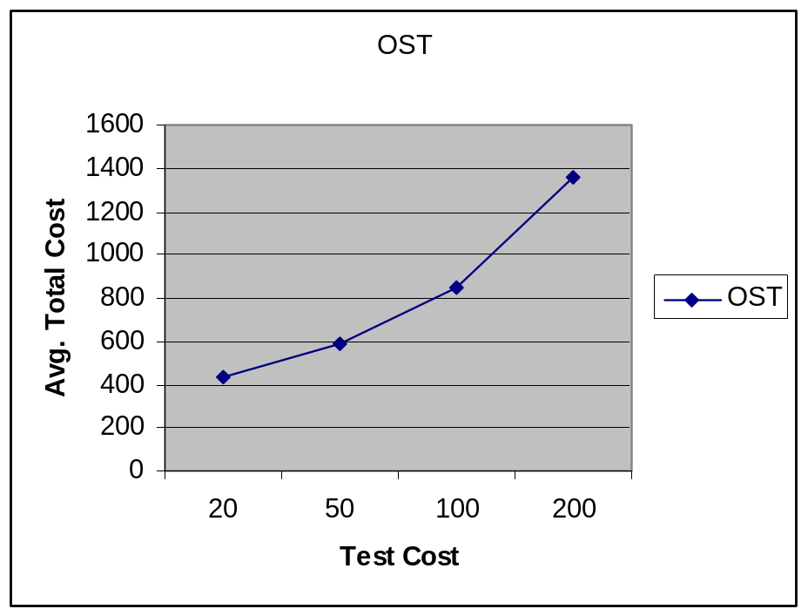
Figure-5: Comparision under different test costs for OST Strategy

- M1: Eliminate the column having missing values.

For this strategy we consider Test Cost on x-axis and Avg. Total cost on y-axis.
Misclassification cost is set as FP = 400, FN = 400.
Test Cost | Avg. Total Cost
20 | 1164.44
50 | 1444.44
100 | 1911.11
200 | 2844.44

Table-8: Avg. total cost for M1 Strategy

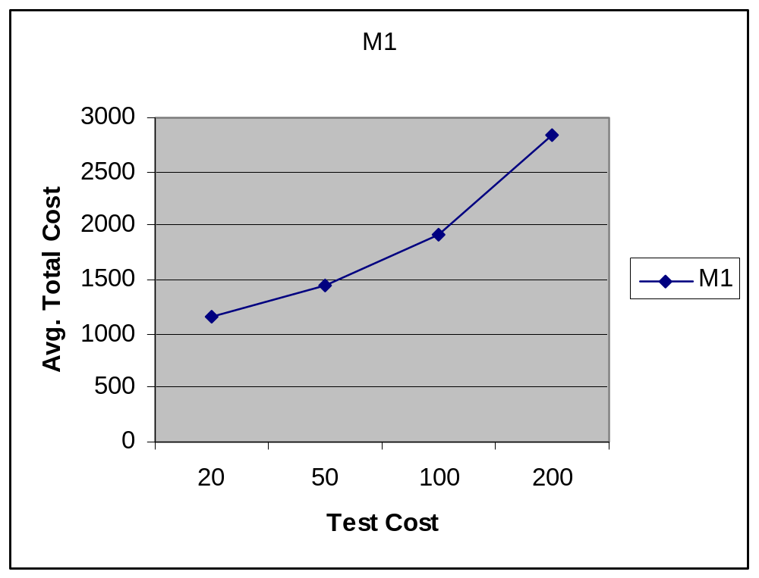
Figure-6: Comparision under different test costs for M1 Strategy

- M2: Build a sub-tree for missing values.

For this strategy we consider Test Cost on x-axis and Avg. Total cost on y-axis.
Misclassification cost is set as FP = 400, FN = 400.

Test Cost | Avg. Total Cost
20 | 854.99
50 | 1130.82
100 | 1461.66
200 | 1563.88

Table-9: Avg. total cost for M2 Strategy
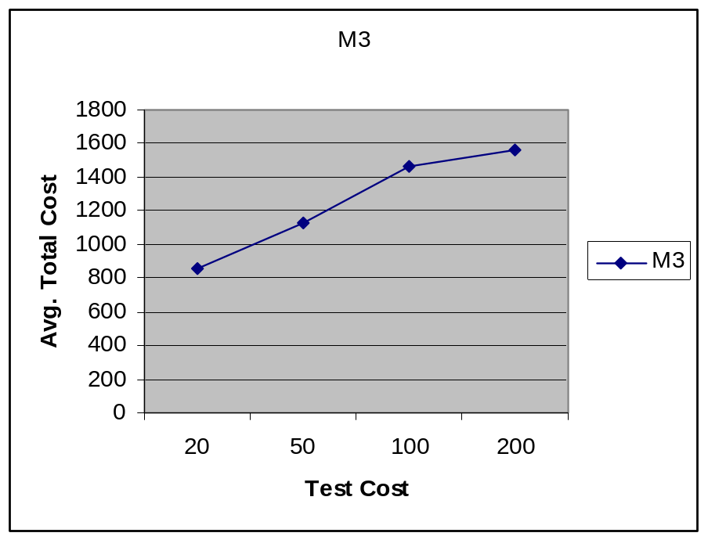
Figure-7: Comparision under different test costs for M3 Strategy

- M3: Not to build a sub-tree for missing values (directly form a leaf with unknown values).

For this strategy we consider Test Cost on x-axis and Avg. Total cost on y-axis.
Misclassification cost is set as FP = 400, FN = 400.
Test Cost | Avg. Total Cost
20 | 854.99
50 | 1130.82
100 | 1461.66
200 | 1703.33

Table-10: Avg. total cost for M3 Strategy

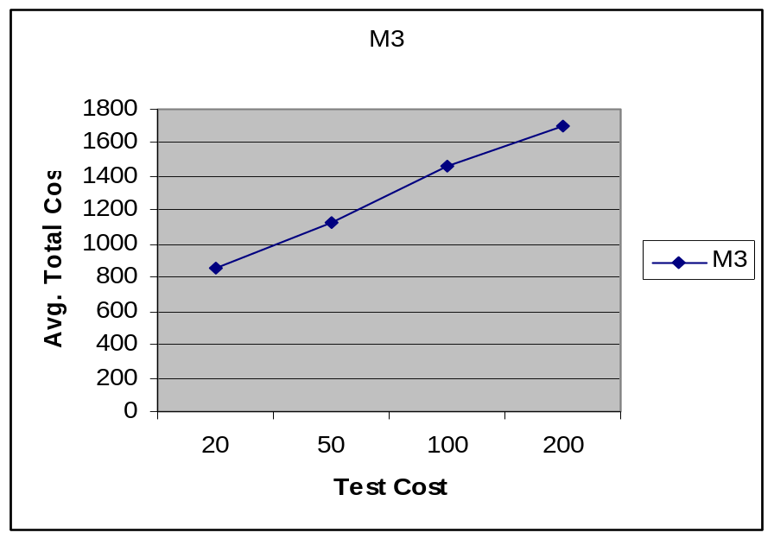
Figure-8: Comparision under different test costs for M3 Strategy

b). Percentage of unknown values Vs Avg. Total Cost.

- OST: Built a decision tree with minimal cost.
For this strategy we consider Percentage of unknown values on x-axis and Avg. Total cost on y-axis.
Misclassification cost is set as FP = 200, FN = 600.

% of Unknown Attribute | Avg. Total Cost
21.24 | 431.66
42.85 | 544.55
57.14 | 506.66
78.57 | 1253.75

Table-11: Avg. total cost for OST Strategy
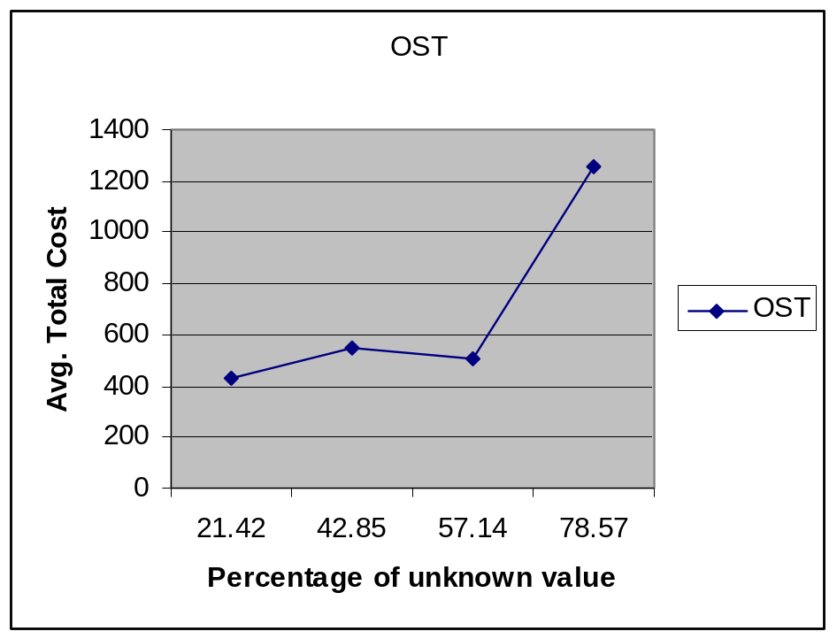
Figure-9: Comparison under different unknown values for OST Strategy

- M2: Build a sub-tree for missing values.

For this strategy we consider Test Cost on x-axis and Avg. Total cost on y-axis.
Misclassification cost is set as FP = 400, FN = 400.
% of Unknown Attribute | Avg. Total Cost
21.24 | 854.99
42.85 | 663.33
57.14 | 821.11
78.57 | 866.38

Table-12: Avg. total cost for M2 Strategy

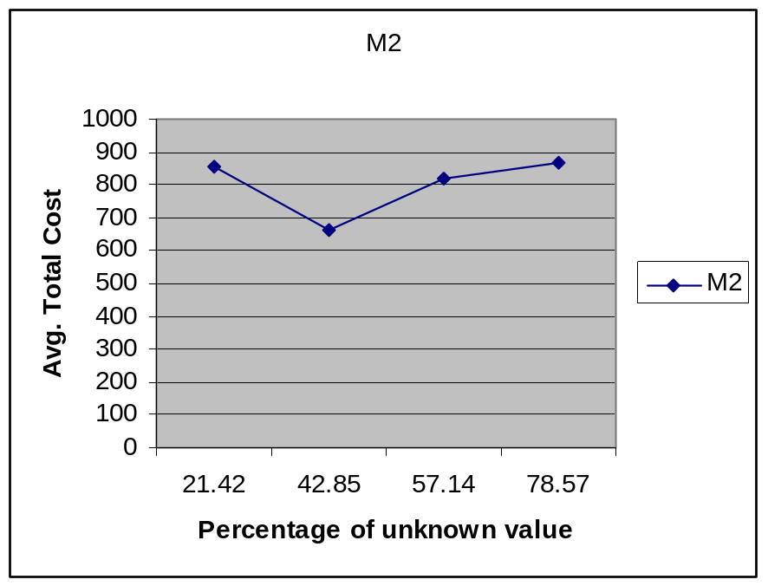
Figure-10: Comparison under different unknown values for M2 Strategy

- M3: Not to build a sub-tree for missing values (directly form a leaf with unknown values).

For this strategy we consider Test Cost on x-axis and Avg. Total cost on y-axis.
Misclassification cost is set as FP = 400, FN = 400.

% of Unknown Attribute | Avg. Total Cost
21.24 | 854.99
42.85 | 867.77
57.14 | 1096.665
78.57 | 1925.38

Table-13: Avg. total cost for M3 Strategy

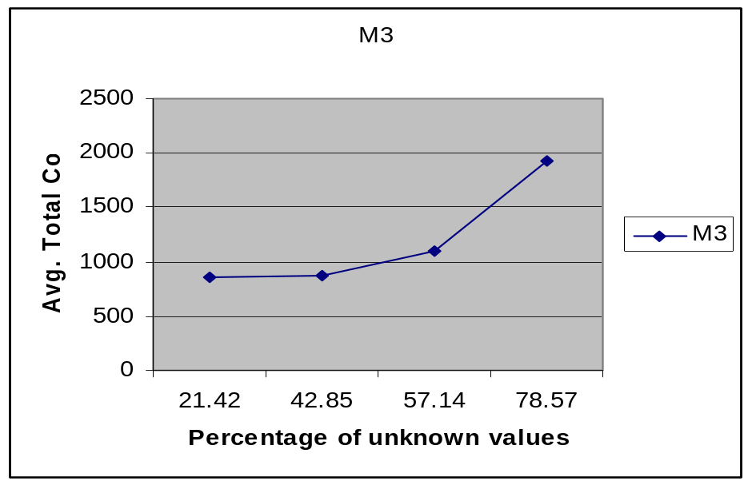

Figure-11: Comparison under different unknown values for M3 Strategy

5.4 Conclusion of Graphical Method

- Total cost is not increase much when percentage of unknown attribute values increase.
- When too many unknown attributes (such as 80%), the decision tree builts from only 20% of known attributes is obviously inaccurate, thus misclassification cost increase dramatically, increasing total cost.
- In some graph, we can see that their performance degrades as the unknown values increases.
- As total cost increase, average total cost also increase.
- For OST method, total cost does not increase much when test cost increase because our tree building algorithm and test strategies aim at minimizing total test cost and Misclassification cost.
CLASSIFICATION USING DECISION TREE

6.1 Training Dataset

Refund | Material Status | Taxable Income | Class
Yes | Single | > 80K | No
No | Married | > 80K | No
No | Single | <= 80 | No
Yes | Married | > 80K | No
No | Divorced | > 80K | Yes
No | Married | <= 80 | No
Yes | Divorced | > 80K | No
No | Single | > 80K | Yes
No | Married | <= 80 | No
No | Single | > 80K | Yes

Table-14: Training dataset used for decision tree construction

6.2 Decision Tree for training dataset
Following decision tree is constructed for above training dataset.

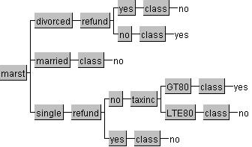

Figure-12: Decision Tree constructed from training dataset

6.3 Testing Dataset
Refund | Material Status | Taxable Income | Class
No | Single | <= 80K | ?
Yes | Married | <= 80K | ?
Yes | Divorced | > 80K | ?
No | Single | > 80K | ?
No | Divorced | <= 80K | ?

Table-15: Testing dataset with unknown class values

6.4 Classification using Decision tree
Decision tree is mainly used for classification, i.e. to find the class labels of unknown values. We know that in decision tree leaf nodes represents the class value. In testing dataset class values are unknown so we find the class values by using decision tree generated from training dataset.
Refund | Material Status | Taxable Income | Class
No | Single | < 80 K | ?

Figure-13: Decision tree used for classification

Refund | Material Status | Taxable Income | Class
No | Single | < 80 K | No

STRENGTH AND WEAKNESS OF DECISION TREE

7.1 Strength of Decision Tree

  - Simple to understand and interpret.
  - Require little data preparation.
  - Able to handle both numerical and categorical data.
  - Can be combined with other decision techniques.
  - Robust.

  - Weaknesses of Decision Tree

- Less appropriate for estimation of a continuous attribute.
- Prone to error for small number of training examples.
- Expensive to train.
GRAPHICAL USER INTERFACE

8.1 Initial GUI:

After running the program GUI will appear to user as shown in Figure-14.

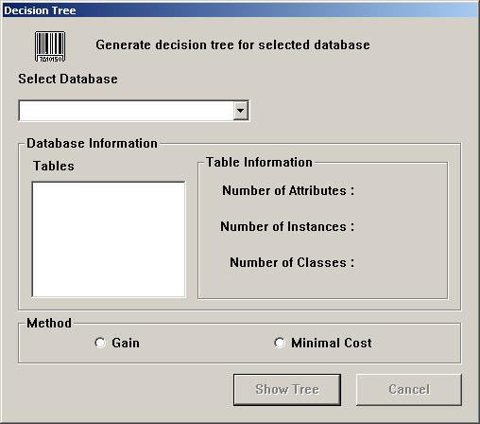
Figure-14: Initial GUI
8.2 Generating Decision Tree for Selected Database - Gain method
Decision Tree can be generated using Minimal Cost Method as shown in following Figure-15.

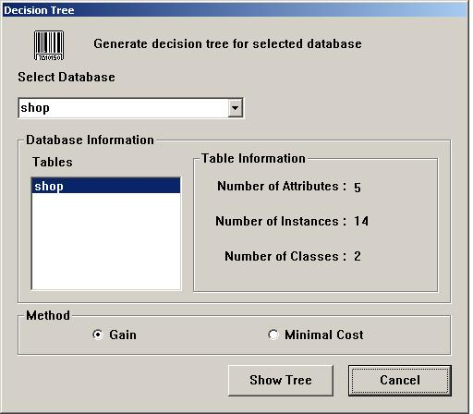

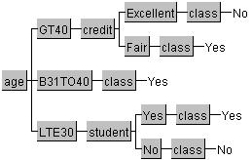

Figure-15: Generating Decision Tree for Selected Database - Gain method
8.3 Generating Decision Tree for Selected Database – Minimal Cost Method
Decision Tree can be generated using Minimal Cost Method as shown in following Figure-16.
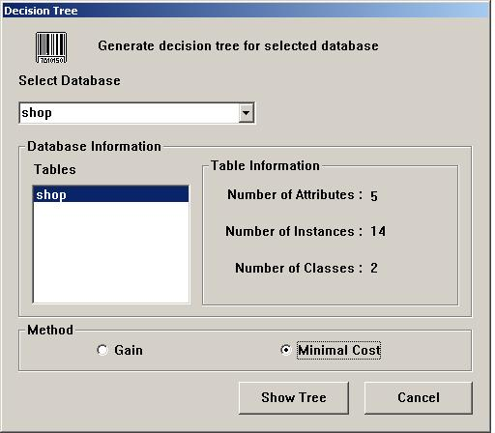
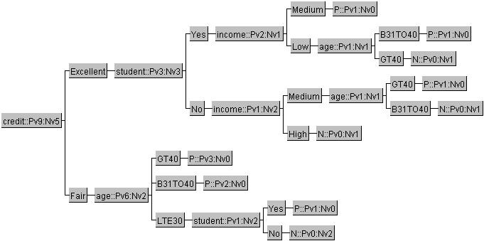
Figure-16: Generating Decision Tree for Selected Database – Minimal Cost Method
CONCLUSION

9.1 Conclusion of decision tree building methods

- Decision tree building methods are best way to obtain classification.
- Minimal cost decision tree minimizes misclassification cost and test cost.
- Computational complexity of this algorithm is very low

9.2 Future work

- We plan to study ways to incorporate other types of cost in our decision tree learning and test algorithm.
- Pruning can be introduced in our tree building algorithm to avoid over fitting the data.

